## Register as a new trader

Expected Result: Trader registration form is displayed



## Register with invalid details

Expected Result: Access to registration denied



## Register with valid details

Expected Result: Registration process is successful

## E-mail Verification

Expected Result: Trader is verified via e-mail



## Trader login with valid details

Expected Result: Trader is successfully logged in after admin approval



## Trader login with invalid details

Expected Result: Access denied



## Add trader type

Expected Result: Trader type is added and awaits approval from the admin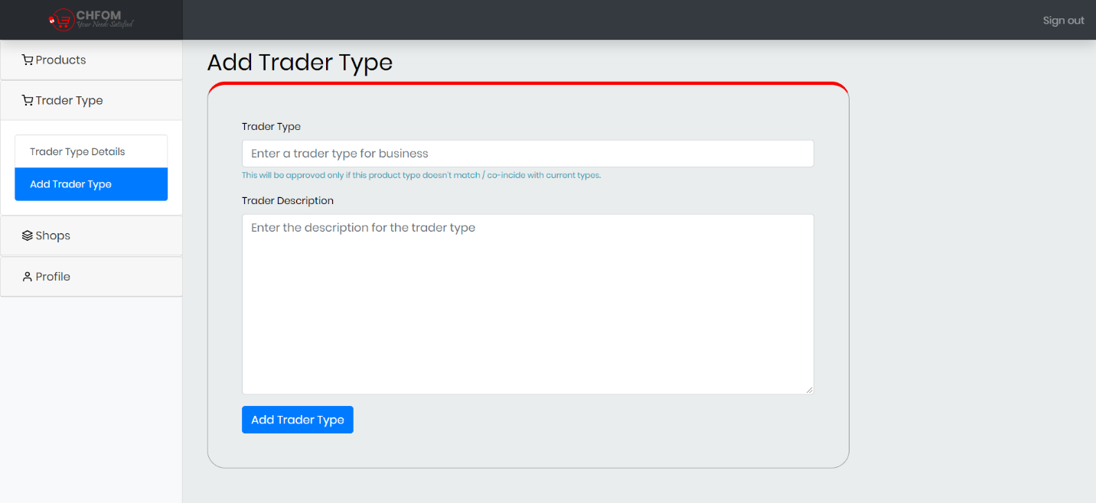

## Traders can add shop

Expected Result: Shop is added for the trader

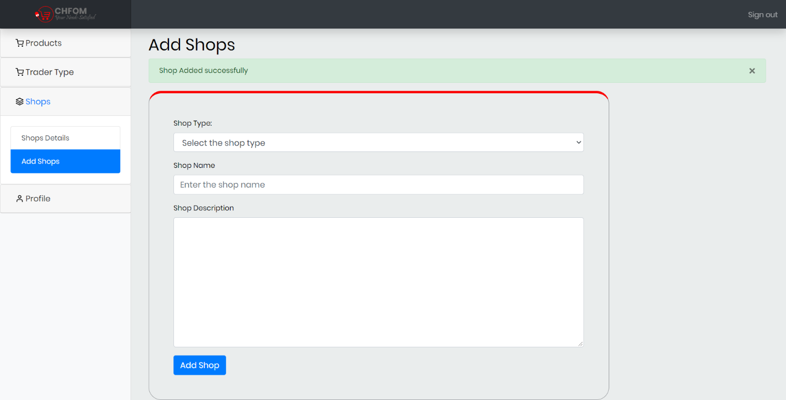

## Add new products

Expected Result: Trader can add new products

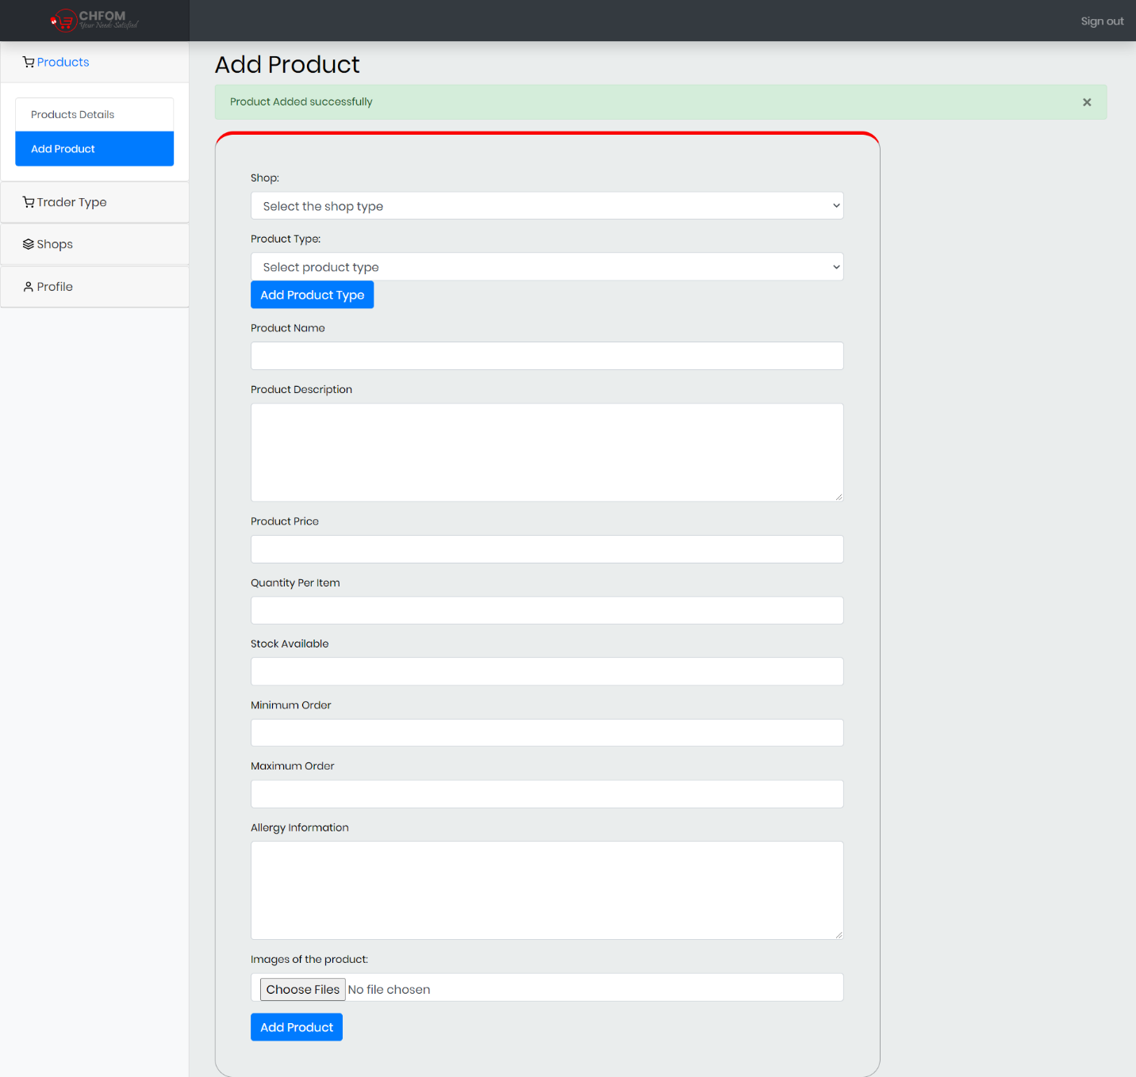

## Update existing product details

Expected Result: Trader can update details of existing product



## Delete existing product

Expected Result: Trader can delete product

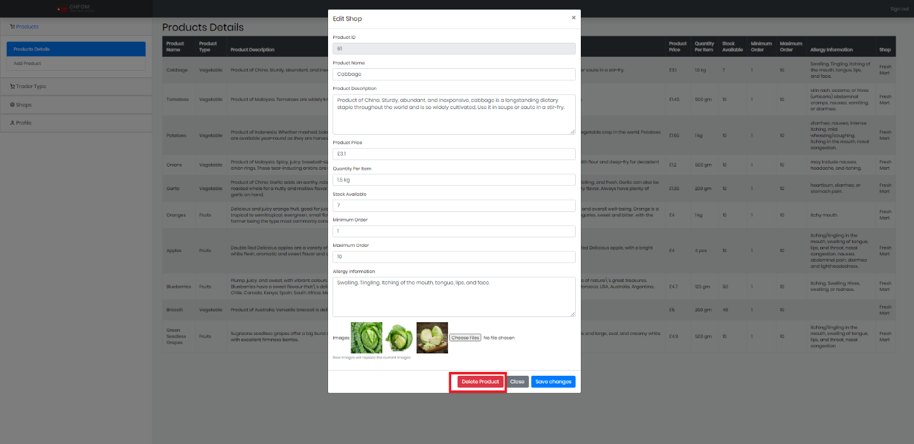

## Logout

Expected Result: Login Page is displayed

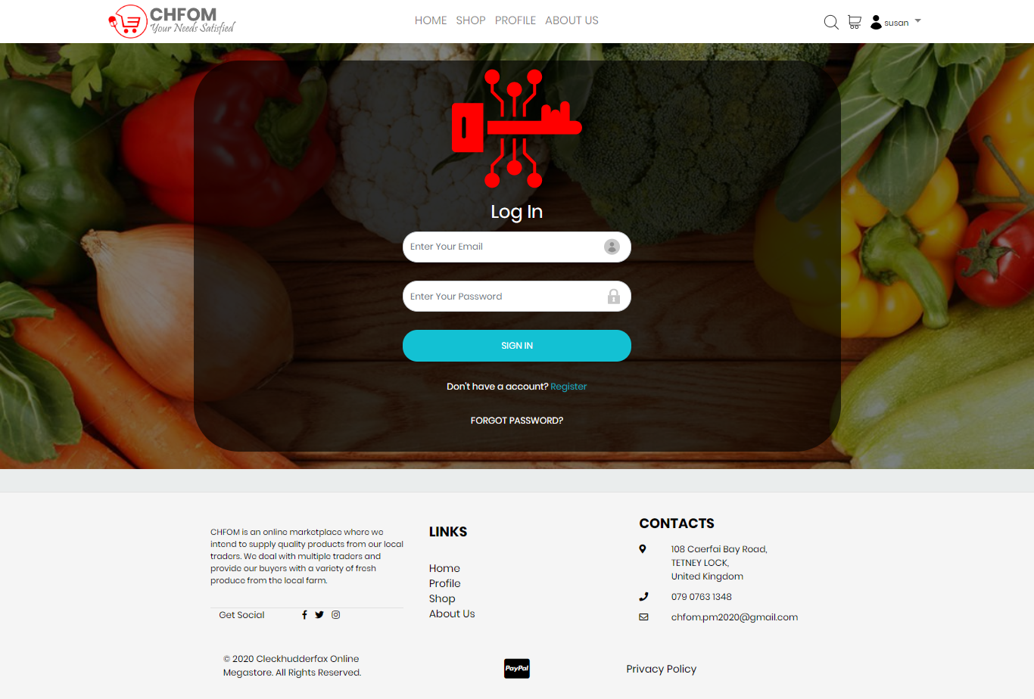

## View Profile

Expected Result: Trader can view their profile

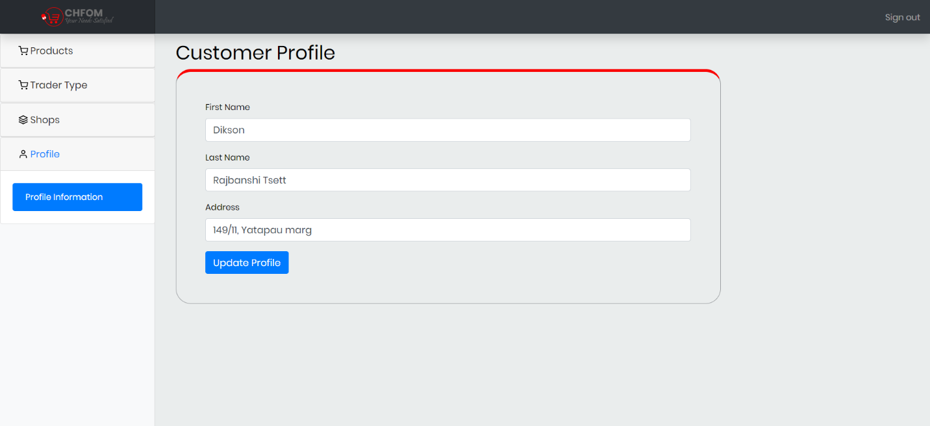

## Update Profile

Expected Result: Trader can edit their profile

